A1026-Mex-Mayan-Jaina Island-Embracing Couple-Ceramic-Late Classic-Phase I, 600-800 CE

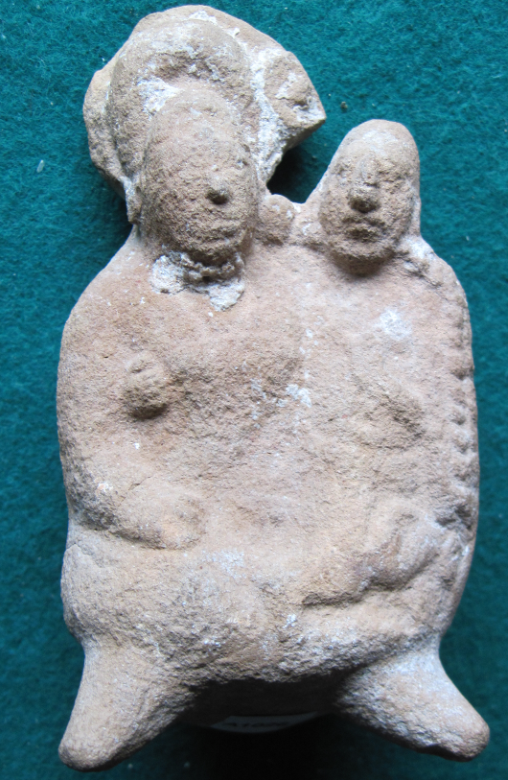 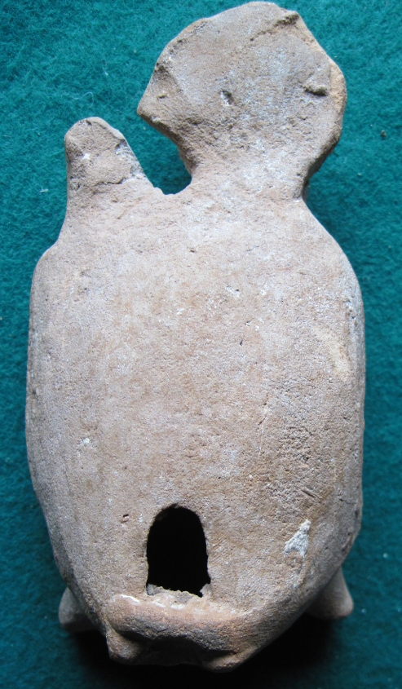

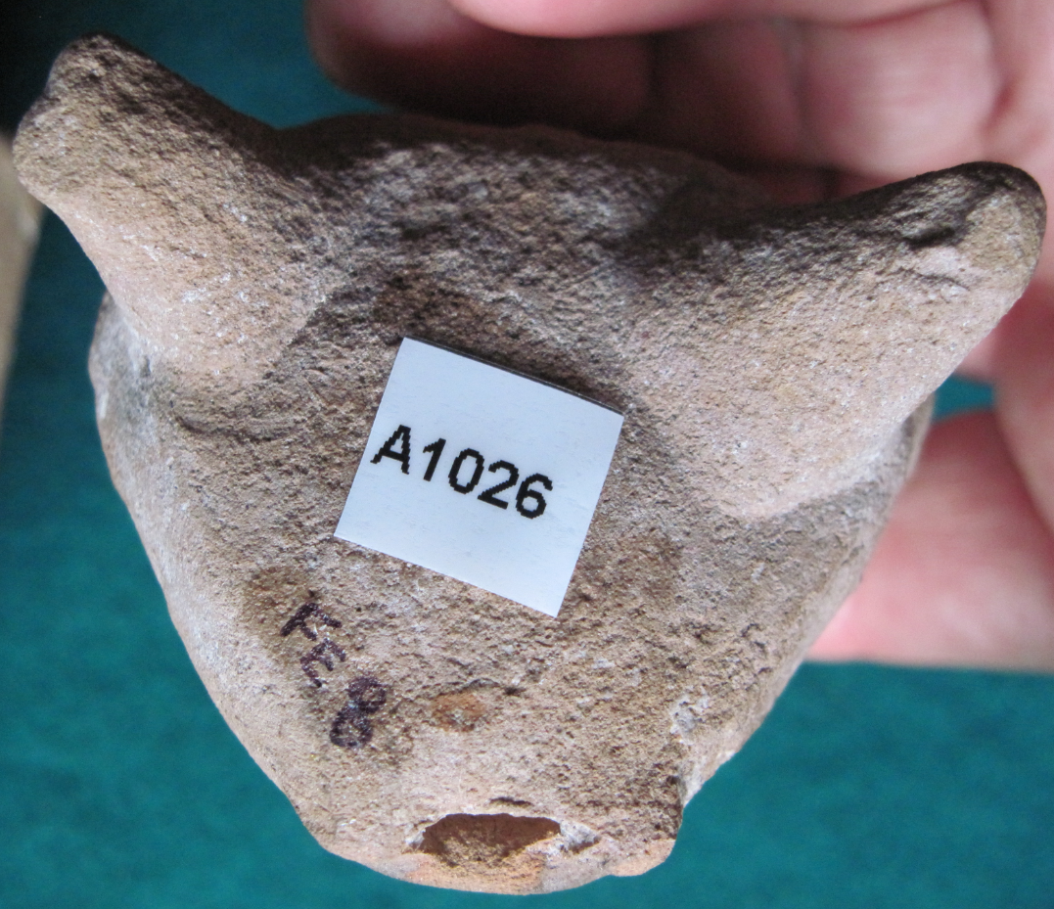

Figs 1-3. Mex-Mayan-Jaina Island-Embracing Couple-Ceramic-Late Classic-Phase I, 600-800 CE

**Case no.:**

**Accession Number: A 1026**

**Formal Label:** Mex-Mayan-Jaina Island-Embracing Couple-Ceramic-Late Classic-Phase I, 600-800 CE

**Display Description:**

This figurine, which was found on Jaina Island, was manufactured in Phase I 600 – 800 AD/CE of Jaina ceramic styles in which figurines were hand-modeled and pigment was applied after the clay had dried. Phase I figurines show the greatest degree of craftsmanship, and, while recurring subjects and styles can be identified such as the tenderness of couples there is an emphasis on the uniqueness of individuals and their facial expressions.

However, an alternative explanation can be offered for this figurine. The embrace may have been sexualized here (see the right hand of the male on the female’s right breast). In the Dresden Codices the woman figure may be the young Moon Goddess Ixchel (Miller 1975). As the moon goes through its phases so too does Ixchel cycle through various male lovers who, in this case, is an older male figure possibly equated with God N, creator of the sky (Taube 1992: 94).

**LC Classification:** F1435.1.J3

**Date or Time Horizon:** 660-800 CE

**Geographical Area:** Jaina Island

**Map, GPS coordinates:** 20.20750 -90.48389;40° 26' 46" N 79° 58' 56" W.

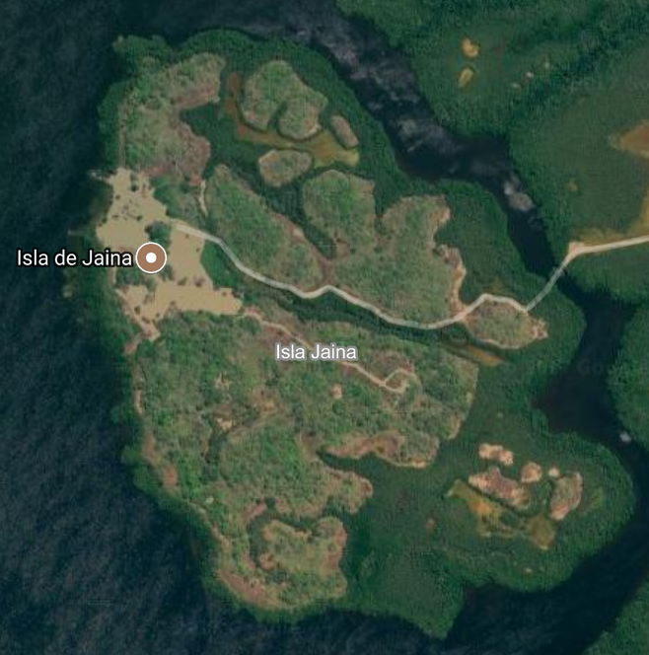 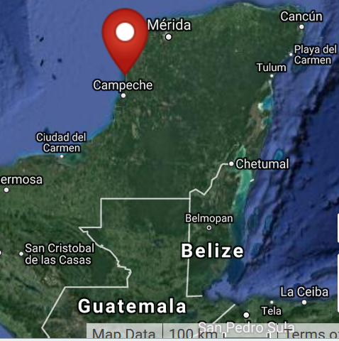

**Cultural Affiliation:** Jaina Phase I figurine

**Media: clay, kaolin pigment**

**Dimensions:** H 113.69 mm; 4.48 in

**Weight: 154 gm; 5 3/8 oz.**

**Condition: original**

**Provenance:** unknown.

**Discussion:**

Jaina Island, also known as "Temple in the Water" (Birmingham [Alabama] Museum of Art 2010: 85) is on the Yucatán Peninsula's limestone gulf coast and is separated from the mainland by a tidal inlet. It served as an élite Maya burial site where fine ceramic funereal wares were interred with the deceased (Coe 1999: 143-144). However, these figurines may have been manufactured on the Campeche coast which was involved in marine trade and exchange with Jaina Island.

Why was Jaina Island selected as the repository of so many mortuary figurines? The answer may lie with the *Popol Vuh* that proclaims all creation began in the sea: "Whatever there is that might be is simply not there; only the pooled water, only the calm sea, only it alone is pooled" (Tedlock 1985: 64). The Bearer and Begetter, who were in the water, created life. For the Maya both the beginning and the ending of humanity is in the waters to the west, and Jaina Island is one of the western-most landmasses off the coast off Campeche.

**References:**

[Birmingham [Alabama] Museum of Art](https://en.wikipedia.org/wiki/Birmingham_Museum_of_Art). 2010. [*Birmingham Museum of Art: guide to the collection*](http://artsbma.org). [Birmingham, Ala]: Birmingham Museum of Art.

Coe, Michael D. 1999. The Maya. 6th ed. New York: Thames & Hudson.

Corson, Christopher. 1973. "Iconographic Survey of some principal figurine subjects from the mortuary complex at Jaina, Campeche,” University of California Berkeley, Archaeological Research Facility, *Contributions* 18: 51-75.

Corson, Christopher. 1975. *Maya Anthropomorphic Figurines from Jaina Island, Campeche*.  [Ballena Press studies in Mesoamerican art, archaeology and ethnohistory](http://www.worldcat.org/search?qt=hotseries&q=se%3A%22Ballena+Press+studies+in+Mesoamerican+art%2C+archaeology+and+ethnohistory%22), no. 1. Ramona, Calif.: Ballena Press.

Corson, Christopher. 1977 [1975]. “Stylistic evolution of Jaina figurines.” In Cordy-Collins, Alana and Jean Stern, Pre-Columbian Art History: Selected Readings. Palo Alto: Peek Publications, pp. 63-68. Previously published in the Masterkey (1975) 40:4.

Miller, M. E. 1975. *Jaina Figurines: A Study of Maya Iconography*. Princeton: Princeton University Art Museum.

Pina Chan, Roman. 1968. *Jaina: la casa en el agua*. Mexico City: Instituto Nacional de Arqueologiá e Historia.

Ruz, Alberto. 1969. “La Costa de Campeche in los Tiempos Prehispanicos,” Investigationes 18. Mexico City: Instituto Nacional de Arqueologiá e Historia.

Stone, Andrea, and M. Zender. 2011. *Reading Maya Art. A Hieroglyphic Guide to Ancient Maya Painting and Sculpture.* London: Thames and Hudson.

Tedlock, Dennis. 1985. *Popul Vuh. The Definitive Edition of the Mayan Book of the Dawn of Life and the Glories of Gods and Kings.* New York: Simon & Schuster.